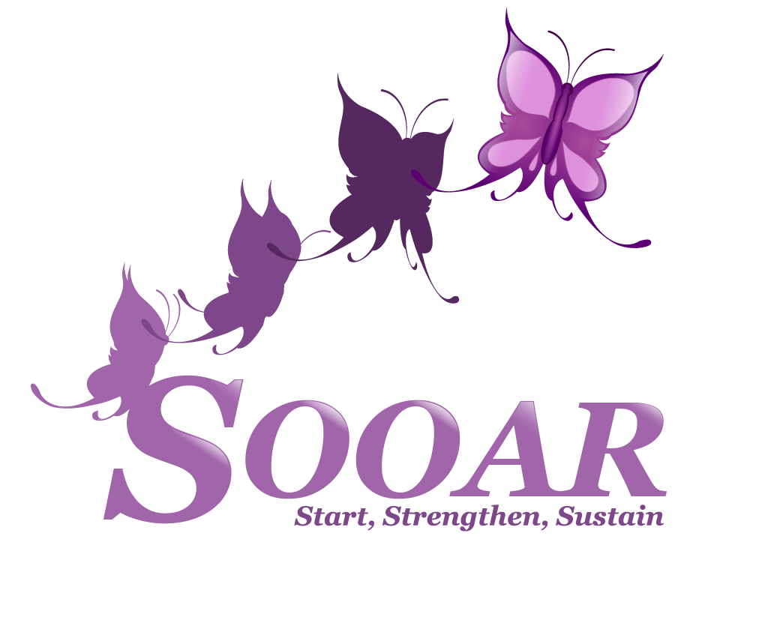

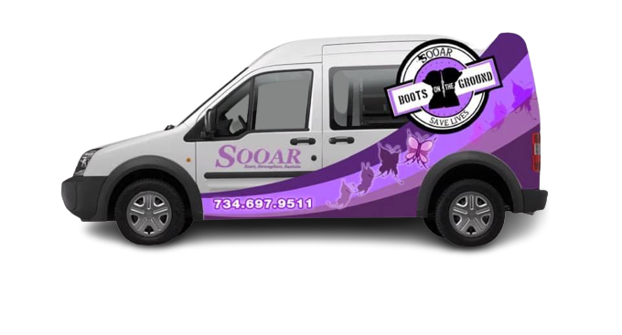

Mobile Outreach Toolkit
Strategies to Overcome Obstacles and Avoid Recidivism
Table of Contents
A. SOOAR Overview 2
B. Community Overview and Context 3
C. Community Partners 4
D. Boots on the Ground History 5
E. Stakeholder and Community Engagement 7
F. Boots on the Ground Overview 8
G. Mobile Health Unit Cleaning, Maintenance, & Infection Control 12
H. Staffing and Supplies 13
I. BOG Mobile Unit Safety 14
J. Outreach & Engagement 17
G. Program Evaluation 21
H. Program Evaluation Outcomes Snapshot 22
I. Logic Model 23
J. SOOAR Community Engagement Project FY2022 24
K. Summary and Conclusions 25

SOOAR Overview
SOOAR is a non-profit corporation and a licensed Community Awareness Information and Training (CAIT) Provider by the State of Michigan Department of Community Health Substance Abuse division that provides prevention, life skills, harm reduction, and community mobilization services.

We are proud of the many ways we remove barriers and improve quality of life for participants and the community at large. Our team empowers adults and youth who use drugs and engage in sex work, including transgender, non-binary, and gender non-conforming individuals, by establishing a safe a brave space that allows for an exploration of the ways in which substance use can affect them both positively and negatively.

Mission: By implementing leadership strategies we encourage, enlighten, and empower low-income and at-risk individuals by integrating life skills programming, harm reduction, and substance use prevention services stimulating positive personal change that leads to more productive lives.

Vision: The overall vision of Strategies to Overcome and Avoid Recidivism is to be the leader in providing high-quality prevention programming by working collaboratively with participants, stakeholders, community partners, educational systems, and corporate partners.

Services:
- Human trafficking awareness and prevention trainings for community organizations
- Connecticut Center for Addiction Recovery (CCAR) Peer Recovery Coach training
- Harm reduction services, including mobile harm reduction (Boots on the Ground)
- Distribution of sterile injection and harm reduction supplies
- Education
- Overdose prevention
- Intervention
- Mental health referrals
- HIV and Hepatitis C testing referrals
- Faith in harm reduction Called 2 Care ministry services
- QPR suicide prevention trainings and 13 Reasons Why Not youth suicide prevention trainings
- Naloxone overdose prevention trainings
- Synar project to reduce illegal retailer distribution and sale of tobacco products to youth under age 21
- Youth life skills programming

SOOAR has multiple locations in Wayne County, Michigan. Please contact Valerie Kelly-Bonner or Trisché Duckworth at (734) 697-9511 with any questions. You may also submit an inquiry at https://www.sooar-nonprofit.org/contact-us.

Community Overview and Context
The overdose epidemic is one of the nation’s most serious health crises. From 1999 to 2019, over 630,000 people died from drug overdoses in the US, and 2.5 million Americans meet the criteria for opioid use disorder (OUD). OUD is treatable, and fatal overdoses can be prevented. Harm Reduction Services in Mobile Outreach Units play a crucial role in linkage to care.

Even in areas where people are within short distances of healthcare and addiction services, people who use drugs (PWUD) still consistently miss opportunities for support, and overdose rates remain high. In response, in partnership with Michigan Department of Health and Human Services, SOOAR, has developed an innovative mobile health program concept called Boots On The Ground (BOG) harm reduction program, the first program in Wayne County, outside the City of Detroit, which aims to expand access to addiction services through mobile health.

PWUD are a vulnerable group who are disproportionately impacted by stigma and prejudice, particularly PWUD of color. These disparities are only growing. Non-fatal illicit drug poisonings have increased by 30% reported by tracking agencies, but Syringe Services Programs participants are reporting around an 80% increase in Naloxone usage without calling 911. Michigan has had a significant increase in fatal illicit drug poisonings, up 19% across the state in 2020, but up over 40% for Black individuals (MDHHS, 2021). Additionally, Hepatitis C Virus (HCV) has increased throughout Michigan, with 62% incarcerated individuals stating a lack of access to sterile supplies as a factor. Injection drug use and lack of access to sterile supplies in 18-39 year olds was reported in 82% of individuals living with HCV (MDHHS, 2021). Furthermore, in Wayne County, as of December 12, 2021, there have been 6,110 deaths due to COVID-19, with a disproportionate impact on Black and Indigenous residents. (MDHHS, 2021).

SOOAR’s BOG mobile harm reduction program provides compassionate services aimed at increasing access for people at highest risk of overdose. BOG deploys a mobile unit and a team of harm reduction outreach workers to areas with high rates of opioid use and overdose to engage individuals and link them to desired resources. By mobilizing critical addiction services, harm reduction teams can bring care directly to high-risk individuals who are currently disengaged from care due to multiple barriers and stigma. Led by individuals with lived experiences of drug use, criminalization, racism, and systemic barriers, BOG aims to increase community access for PWUD. SOOAR is proud to be part of a continuum of care that partners clinical and harm reduction providers to support optimal health and quality of life for all PWUD and sex workers, particularly those disproportionately impacted by systemic racism, stigma, homophobia, transphobia, and poverty.

Community Partners

SOOAR’s services and BOG harm reduction initiative were made possible with support from numerous partners. SOOAR is committed to forming partnerships built on shared goals and trust, to respond more effectively to the needs and reduce the harms for people who use or have used drugs. Our partners include, but are not limited to the following:

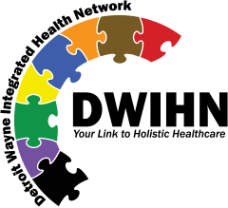
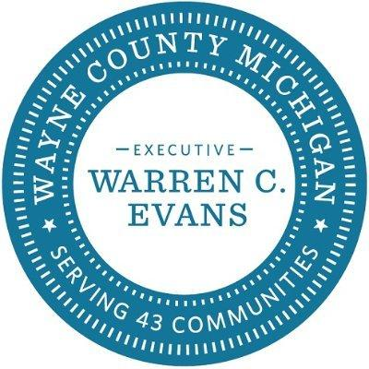

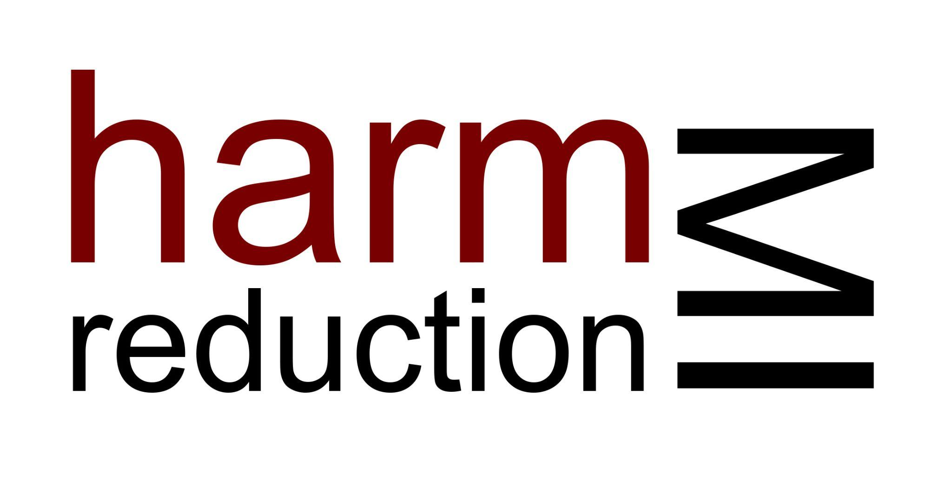

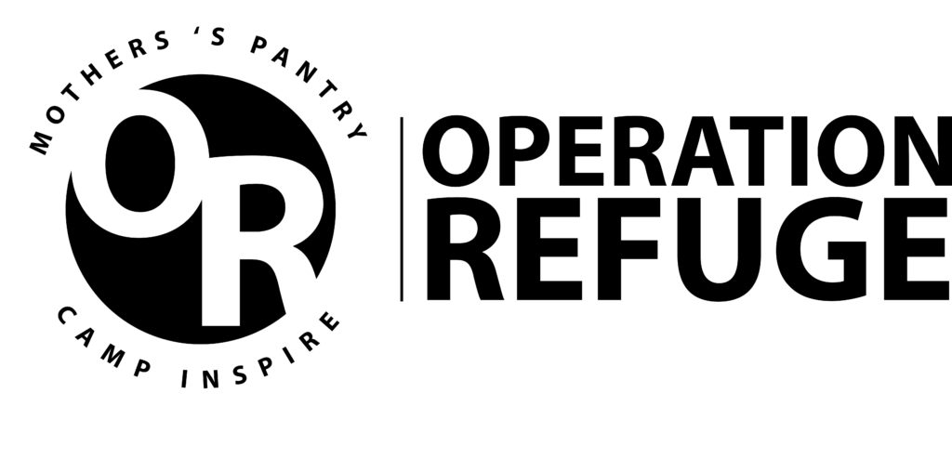

Boots on the Ground History
Overdose and HIV infection rates were skyrocketing in Wayne County. In May of 2020, The Executive Director of SOOAR, Valerie Kelley-Bonner, was approached by the Substance Use Disorder Director of Detroit Wayne Integrated Health Network and members of the Michigan Department of Health and Human Services Viral Hepatitis Division to assist with the creation of a harm reduction program in Out-Wayne County. The creation of a Syringe Service program was a viable solution to combat the problem. However, decriminalization of paraphernalia had to occur for the program to operate legally and be successful. The first City approached was the City of Inkster. The ordinance was drafted and unanimously approved in 60 days. SOOAR was the first agency to legally operate a Syringe Service Program outside of the City of Detroit. This victory was the beginning of Boots on the Ground (BOG).

SOOAR has always operated under the premise, “nothing for them without them.” Therefore, the BOG Outreach Team began to canvas the city interacting with community members and people who use drugs. This interaction was integral to the success of the program; it built trust, teamwork, mutual admiration, and respect. The needs of participants were heard, and the Team acted distributing clean works, items for the houseless, and letting the participants know that they are loved, and they are not forgotten.

The Team saw the need to integrate spirituality into the program. Several churches were asked to collaborate to no avail. This was very discouraging and baffling; Jesus Christ walked with the broken. It was a harsh realization to discover that the local church didn’t really care. Through the disgust and pain, it was clairvoyant that the BOG Team was “called to care”. This was the birth of “Called 2 Care Ministries,” the spiritual branch of the operation.

Boots on the Ground is a no judgment zone. We are not in the business of forcing transformation on anyone, rather we will foster an environment that allows transformation to take place. We are proud of the success we have made in such a short period of time and looking forward to continuing to pave the wave for those who need us most.

Involving PWUD
After determining there is sufficient need for mobile services, continued input and engagement from PWUD is important to ensure the services best meet the needs of those at greatest risk for overdose, STIs, violence, and injuries. The team should consider conducting ongoing surveys and engaging in continued consultation with PWUD to solicit their expertise and feedback on:

- Acceptability of the program to PWUD
- Aspects of the program design, including service hours and location
- Potential barriers to accessing services
  - Staff and team engagement with PWUD, including strengths-based, participant-centered approaches

Continued focus groups, surveys, and key informant interviews are critical to continue tailoring the program to best meet the needs of PWUDs. Careful attention should be paid to PWUDs’ concerns about criminalization, stigma, and how any information they share will be used. The team should make every effort to be upfront about confidentiality, how the insights will be used, and when, and how PWUD will be informed of any adaptations made to the program stemming from these insights.

Additionally SOOAR will be present at local Community Board and Precinct Community Council meetings as needed in order to represent agency interests and participate in local problem solving as issues arise.

SOOAR Syringe Services Program (SSP) will also establish a Participant Advisory Group made up of SSP and program participants to provide input and guidance on program policies and operations. SOOAR aims to support the PAG in meeting a minimum of once per month. If this proves unrealistic then they will be scheduled for every two months. The Program Director will be responsible for scheduling the initial meeting in the hope that a leader will emerge from this group who is willing to take on the responsibility of leadership with the technical assistance of a SOOAR Outreach staff if necessary. There will be no initial cap on the number of participants allowed to participate in PAG meetings; if it is later decided by the PAG to change this policy, a request will need to be submitted, in writing, to the Program Director. If the SOOAR SSP is unable to identify program participants who are willing to serve on the Participant Advisory Group, semi-annual or quarterly focus groups may be convened to elicit input from users and members of their social networks.

Stakeholder and Community Engagement
Engagement with community stakeholders is crucial to the success of BOG. The team should conduct outreach to community stakeholders to demonstrate the need for BOG’s services and build buy-in. However, the team must make every effort to protect participants’ privacy when presenting data, use aggregated data when possible, and highlight any limitations in the data. Additionally, research on interventions that may be considered controversial should be presented as well, including medications for Opioid Use Disorders.

Engagement with stakeholders should involve sharing about BOG’s design, and offering the opportunity to answer questions and address any stakeholder concerns about BOG. Additionally, input on the location of the mobile unit in the community should be solicited, as well as any concerns about observed participant activity. Establishing memoranda of understanding with stakeholders is vital, and ongoing updates should be provided to community stakeholders as BOG progresses and innovates. Stakeholders should include, at a minimum, City Council representatives, neighborhood liaisons, law enforcement, health center staff, neighborhood coalitions and businesses, houselessness shelter staff, food bank staff, and more.

Some community stakeholders may hold concerns about BOG’s services, including the mobile unit and its use. It is important to prepare for these concerns ahead of time and address them effectively.

CONCERN: Worries that the presence of the BOG’s mobile health unit would lead to long lines of participants or potential participants in the neighborhood.

RESPONSE:
- BOG is intended to be a discreet, targeted service.
- Most outreach is done on foot, and only interested participants are brought back to the mobile unit.
- The goal is not to become a high-caseload program, but to provide stabilization.

CONCERN: Worries that BOG will draw large numbers of individuals from neighboring towns.

RESPONSE: There is a visible overdose crisis in the country and locally. BOG aims to support people at the highest risk of death and harm. Instead of advertising broadly, SOOAR hopes news of the program will spread by word of mouth in order to support community health and wellbeing.

CONCERN: Worries that the BOG mobile unit will result in an increase in discarded needles.

RESPONSE:
- Research shows that participants in syringe services programs (SSPs) are more likely to safely dispose of their syringes.
- Participants in SSPs are more likely to seek treatment for substance use disorders.
- SOOAR staff will be safely disposing of any syringes they come across.
- BOG will incorporate safe disposal education regularly when engaging with participants.

CONCERN: Worries that the target neighborhoods are being unfairly singled out.

RESPONSE: Target areas were selected based on data indicating high rates of fatal and non-fatal overdose.

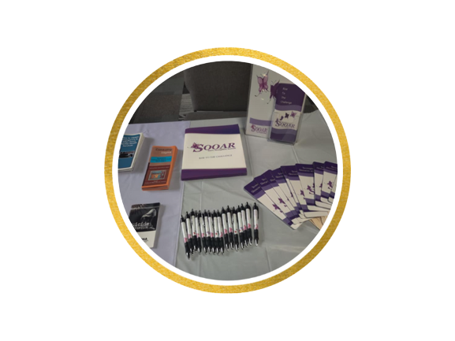
Boots on the Ground Overview

Services
- Safer injection kits
- Safer snorting kits
- Safer smoking stem kits
- Safer smoking bubble kits
- Internal and external condoms
- General hygiene kits
- Menstrual hygiene kits
- Narcan kits (2 doses per kit)
- Substance use management
- Referral to substance use management
- Basic needs (food distribution, food giftcards, housing navigation)
- Basic check-ins (emotional support, mental health navigation)

Budget Considerations
Van specifications & purchasing:
- Adequate space – Staff should consider space requirements for conducting an encounter.
- Privacy – Privacy of participants both during sessions and in waiting for van services.
- Power & Wifi access – Power for medical equipment, laptops, printers, and internet for EHR access.
- Climate control – Heating and cooling systems and fridges should be considered.
- Restrooms – Restrooms increase options for some lab specimen collection.
- Agility – Consider that van size may be an issue in preventing the team from accessing certain locations.
  - Driver considerations – Program resources can be saved if the vehicle does not require the driver to have a commercial driver’s license.
- Available parking – Be mindful of potential parking space sizes to accommodate the van.
- Other considerations – Disability accessibility is often a requirement of mobile units.

Though budgets may vary, there are several categories to consider.
- Capital Costs
    - Mobile unit – Purchase of the vehicle itself with a medical buildout, signage, and branding.
    - Legal support – Consider a legal support team to assist with operating licensures.
  - Annual Operating Costs
    - Clinical team – May include buprenorphine-waivered MDs, NPs, PAs, or a combination to serve as medical providers on the van. Estimated total of 0.75 FTE.
    - Outreach Workers – Provide outreach, harm reduction services, and promote van services among PWUD. Estimated 1.50 FTE.
    - Harm Reduction Care Coordinator & Navigator – Participates in outreach, provides harm reduction services, supports referrals for participants and health insurance enrollment. Estimated 1.00 FTE.
    - Housekeeper – Ensures weekly cleanings of the mobile unit. Estimated 0.01 FTE.
    - Other potential staff – Consider adding a behavioral health clinician and/or social worker to support the mental health needs of program participants.
- Non-personnel expenses
    - Medical equipment/supplies
    - Naloxone
    - Vehicle insurance
    - Gas, maintenance, & upkeep
    - Food for participants
    - Participant transportation
    - Cell phones
    - Sharps/biohazard disposal
- Revenue
    - Incorporate anticipated revenue into budget considerations based on a conservative estimate of average number of clinical visits and reimbursement rates.

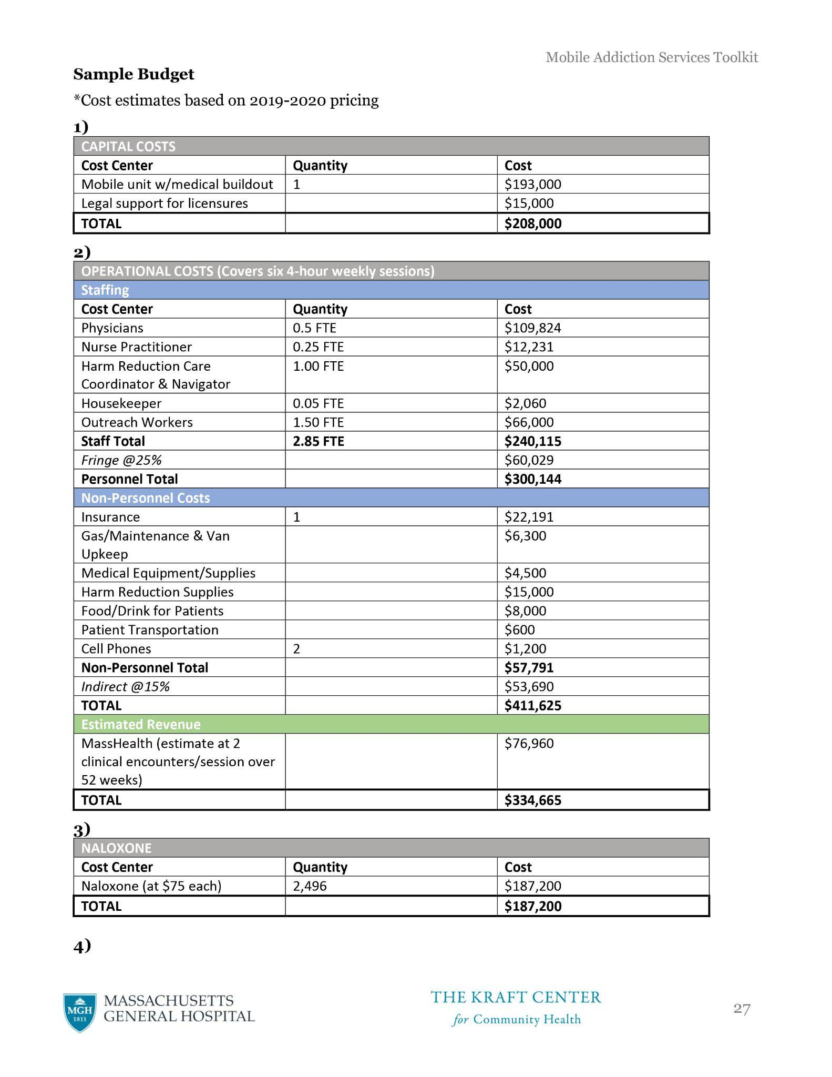
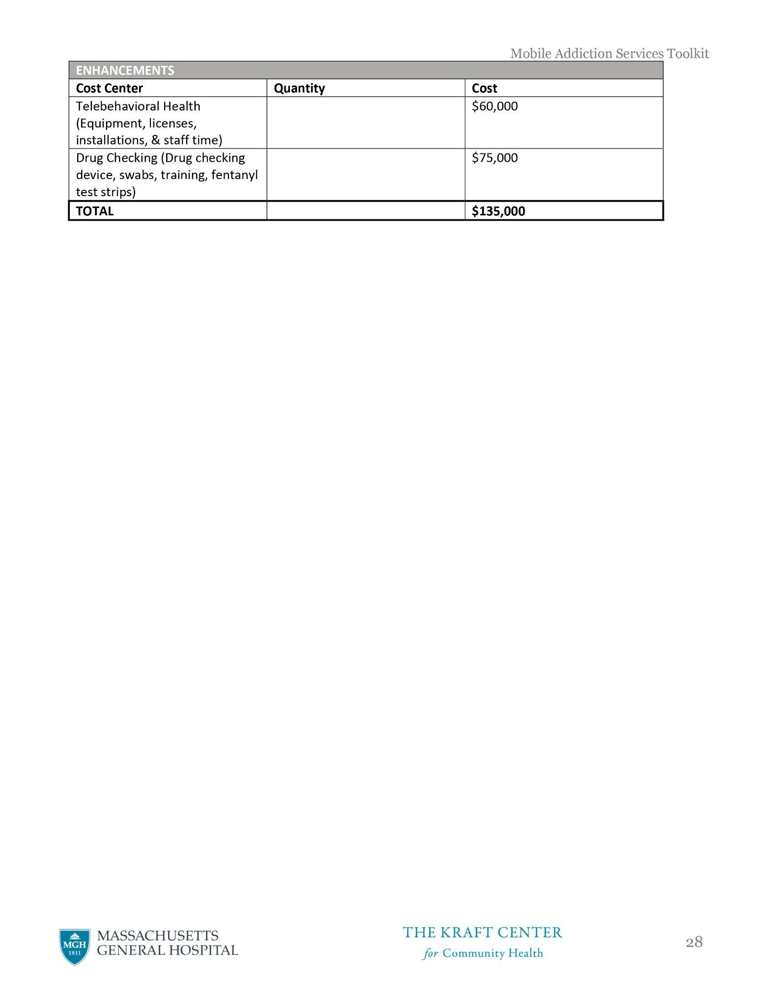
Mobile Health Unit Cleaning, Maintenance, & Infection Control

Cleaning
- After each session, staff should wipe down surfaces and medical equipment with disinfectant.
- The mobile unit should receive a comprehensive cleaning weekly.
- Refrigerators should also be cleaned.

Infection Control
- Standard precautions such as handwashing before and after each clinical encounter should be followed.
- Office-based policies and procedures regarding infection control should be followed on the van.

Medical Waste Policy
- Mobile health team should ensure they have plans and a contracted agency in place to dispose of hazardous materials.
- All biomedical waste materials and containers [including sharps] throughout the mobile unit should be collected quarterly or as needed by staff.
- Staff should follow the schedule and protocols set forth by the contracted agency responsible for removal of hazardous materials.

Mobile Health Unit Maintenance and Cleaning
- The van should be registered and inspected by a private vehicle maintenance company.
- The van should undergo routine mechanical maintenance (e.g. oil change, etc.) every six months.
- The applicable manufacturer’s recommendations will be used as the basis for deciding when vehicle conditions warrant a vehicle’s removal from service.
- Membership should be obtained with an emergency roadside services company to provide mobile unit towing if needed.
- Every other time that the mobile unit is fueled, the oil and coolant levels should be checked.
- Not less than every other month, the exterior of the van should be washed.
- OSHA guidelines should be followed when cleaning up blood or bodily fluids.

Mobile Unit Parking and Siting
- During after-hours, the mobile unit should have a secure, designated parking space.
- Mobile unit operations should only be sited on solid, level parking surfaces.
- Mobile unit siting should maintain a minimum separation of at least 30 feet between the unit and any building outside air intakes or any HVAC or generator exhaust, and at least 20 feet between the mobile unit and any unsprinklered building.
- The unit will be located to allow access to and exit without interference with building exits or fire lanes.

Exchange and Transport of Equipment and Supplies
- At the end of each day, some equipment, including any computers that allow access to the EHR, should be delivered to a secure location. The equipment should then be taken onto the unit by staff the next day of operation.
Staffing and Supplies
The following staff specifications are recommended to support services on the BOG mobile unit.

Buprenorphine-waivered clinician. At least one clinician with the appropriate waiver and training to prescribe buprenorphine and naltrexone should be on the mobile unit during every clinical session. The clinician may be an MD, nurse practitioner, physician assistant, or other qualified health professional depending on the resources available to the program’s clinical partner.

Outreach workers/Harm reduction specialists. Harm reduction services are vital to engaging participants and providing access to supplies and education. Basic competencies for outreach workers:
- HIV/HCV/STI transmission, prevention, & treatment
- Overdose prevention education
- Safer injection education
- Risk reduction strategies around substance use and sexual practices
- Addiction treatment modalities & linkage to care
- Demonstrated current knowledge of HIV/AIDS, STDs, hepatitis and other blood-borne infections, particularly in relation to injection drug use; street life; slang vocabularies; drug use practices; harm reduction concepts and principles; local drug treatment; health care; and criminal justice systems and resources.
- Demonstrated communication skills with the ability to communicate complex information in a culturally appropriate, consistently respectful, and non-judgmental manner
- Strong organizational, interpersonal, written, and verbal communication skills
- Self-directed, motivated, and flexible; can work independently and as part of a team.

Many supplies used during clinical sessions will not be stored on the mobile unit during off hours, based on regulations. Staff should plan to stock the van prior to every session and remove the medicine and equipment upon clinic completion. Staff should also consider stocking outreach bags in case participants need supplies but won’t or can’t access the mobile unit.

BOG Mobile Unit Safety
The safety of the staff or designated representatives, including volunteers, during outreach is a high priority and the responsibility of each team member. In accordance with SOOAR’s policies and standards, each team member is required to adhere to the safety protocols put forth during outreach in order to prevent or minimize any harm occurring to team members, participants, and other bystanders. This policy applies to all clinicians, outreach workers, social service providers, and volunteers who enter and work in SOOAR’s outreach designated areas, including the mobile van, fixed sites, on the streets, in camps and housing units, and any other relevant sites for outreach.

All workers who staff the mobile unit must consistently exercise safe practices by following these procedures:

Training: All workers who staff the mobile unit work must complete a safety training that will include personal safety techniques, de-escalation techniques, risk assessment, and non-violent crisis intervention.

Linkages with crisis response teams and behavioral health support are essential, especially if outreach teams lack a behavioral health provider.

Safety planning and outreach preparation: All workers who staff the mobile unit or conducts outreach must adhere to safety planning, preparation and practice with constant communication among the team.

Staffing Requirements: For the safety of staff, interns, and volunteers, the following practices should be applied:
  - Teams of Two: No one shall conduct outreach or remain on the mobile unit alone. Be sure to conduct all mobile outreach activities in groups no smaller than two people. There must always be at least 2 team members in the mobile van at all times. There must always be at least 2 team members traveling together when visiting sites on foot and on the streets. Each team member must inform the other team member of their activities, particularly if they are leaving the immediate vicinity of the mobile van. If any clinicians or other providers are seeing a patient on the mobile unit, another staff member should also be present on the mobile unit. Teamwork requires trust and cooperation. In teams of two, both staff members leave when either staff person indicates the need to leave a potentially unsafe situation. No one stays behind. Because it may be difficult to leave a potentially dangerous situation without escalating tension and because one staff person may perceive a threat that the other is entirely unaware of, it is important that both agree to leave at any sign the other is ready.
  - Track whereabouts: The mobile team should always discuss the safety action plan before they leave the mobile unit with all staff on the van. A designated staff member not onsite should also be informed of planned outreach routes and estimated return times.

Dress and valuables: Consider avoiding items around the neck like scarves, and jewelry, which can pose a choking risk; leave valuable bags and jewelry at home; leave the mobile unit locked at all times when no team member is aboard and keep valuables out of sight; use of headphones can diminish the ability to hear and may increase vulnerability; agency IDs should be worn at all times (if a lanyard is used, it should be breakaway). Wear matching clothing, ideally in bright colors, so your team is easily identified as the street outreach folks.

Safety Equipment: Should be provided to staff including Breakaway ID lanyards, Agency issued and/or personal cell phone with safety apps (such as Safe Signal App) installed, the option of a toggle, and staff members trained in its use. Personal safety alarms can be considered as well.

Risk Assessment Team members should share risk assessments of program participants at regular team meetings to prepare for upcoming clinics. They must include consideration of both potential safety issues with the particular participants and safety issues ascribed to the particular setting in which the visit will take place. What is the potential for violence with this particular participant or this particular environment?

General Safety Tips: Use “universal precautions,” meaning that every person and every environment is considered potentially dangerous, these can include:
- During visits to be friendly, non-judgmental and kind, but to stay focused on the working relationship and help the program participant reach their goals.
- Trust your instincts. Leave when you sense potential danger.
- Stay alert.
- Know what behaviors provoke you and ways to respond to those behaviors without placing yourself in danger.
- Keep your hands free.
- Keep car keys in your pocket or hand.
- It is important that program participants either manage their own money or work with a formal payee service. Staff may not ever borrow, save, give, use, or exchange money or other valuables, including ATM or EB cards, with participants. This helps to avoid any possible misunderstandings about financial transactions.
- Use harm reduction principles: safety and comfort are two different things, as are perceived threats to safety and actual threats. Witnessing drug use is not necessarily a threat to safety, for example.
- Weapons and mace are tempting aids, but they only serve to escalate the situation if used on people.

Safety During the Visit:
- Never approach a person who is yelling, screaming, or otherwise visibly disturbed.
- Be aware of surroundings and ensure clear access to an escape route at all times.
- Be aware of personal space – keep at least an arm’s length between you and the program participant.
- Have identified safety locations, like organizations, store fronts, and other businesses that would help me to stay safe, use a phone or restroom, and a person that may be able to assist if a situation occurs.

Expectations of Supervisors:
- Keep a list of emergency contacts for each worker who does outreach.
- Ensure the workers have agency-issued cell phones or personal phones and that workers are trained in the use of any safety apps being utilized.
- Develop a safety plan with staff. This plan should be re-evaluated as factors change, according to the need for safety and staff should be supported in order to implement the safety plan.
- Address the threat of violence or the aftermath of violence by attending to the needs of the worker, co-workers, and affected participants. Present an open environment for discussion and learning from successes and concerns.
- Create time and space for street outreach teams to debrief and process any threatening events. Trauma-informed supervision of outreach personnel is essential.
- Provide ample opportunity for debriefing with all involved and offer trauma counseling.

Documentation: details of any incident in a written record kept by the supervisor. Immediately communicate with the appropriate agency staff to report any serious incident and consider if, and when, legal action should be taken. Communicate to other staff instances of work-related violence or significant threats of violence.

Safety Action Plan: The outreach team must develop a safety action plan (“The Plan”). Each outreach team member (“The Team”) must complete training on The Plan.
- A safety word (“The Code”) will be used by any member of The Team in a circumstance or situation where any team member is feeling unsafe. Once The Code is used, The Team will gather and leave the site immediately.
- Have identified safety locations, like organizations, storefronts, and other businesses that would help me to stay safe, use a phone or restroom, and a person that may be able to assist if a situation occurs.
- Any deviation from the planned locations or outreach routes must be reported to all mobile team members and the offsite designee immediately by the method pre-determined by the team (either via phone call, text, or email). If a worker does not return to the mobile unit at the planned time and cannot be reached, the mobile team should contact the worker’s emergency contact.

Mobile Unit Parking and Siting:
- During after-hours, the mobile unit should have a secure, designated parking space that is accessible to the program staff.
- Mobile unit operations should only be sited on solid, level parking surfaces. If the mobile unit has wheel stabilizers, those should be deployed to safeguard against movement when parked on an incline.
- Mobile unit siting should maintain a minimum separation of at least 30 feet between the unit and any building outside air intakes or any HVAC or generator exhaust, and at least 20 feet between the mobile unit and any unsprinklered building.
- The unit will be located to allow appropriate access to and exit from the unit without interference with adjacent building exits or fire lanes.

Exchange and Transport of Equipment and Supplies: At the end of each day of the mobile unit’s operations, some equipment, including any computers that allow access to the data management system, should be delivered to a secure brick and mortar location. The equipment should then be taken onto the unit by staff the next day of operation.

In Case of an Accident: Staff will ensure safety and ensure the following steps are taken:
- Move the vehicle to a safe place if possible.
- Use hazard warning lights and switch off your engine.
- Do not move injured passengers unless they are in immediate danger of further injury.
- Call the emergency services immediately; provide them with information about the situation, any special circumstances, and if any passengers have special needs.
- If the emergency services are called, stay at the scene until they allow you to leave.
- Obtain the names and addresses of all independent witnesses (if possible).
- Ensure the vehicle is roadworthy before continuing the journey.
- If there is any injury or the names of people involved are not exchanged, you must report the accident to the Police as soon as possible or in any case within 24 hours.
- Report the incident to your supervisor and complete an Incident Report.

In Case of a Breakdown:
- Move the vehicle off the road and switch on the hazard warning lights.
- If this is not possible, move it as far away from moving traffic as you can.
- On busy roads, passengers should be taken as far from the traffic as is practical.
- Keep passengers together.
- Call for assistance, giving emergency responders accurate details of the vehicle's location
Outreach & Engagement

Harm Reduction Strategies
Outreach workers will engage PWUD in harm reduction services and strategies, specifically syringe exchange, safer injection techniques, naloxone, and fentanyl testing.
  - Syringe exchange – All outreach workers should carry unused syringes as well as equipment for the safe collection and disposal of used syringes (e.g. gloves & sharps containers).
    - Distribution – During engagement, each person engaged will be offered unused syringes and injection equipment. Each person should also be offered a description or informational material on safer injection practices. Outreach teams should consider a ‘needs-based’ model.
    - Collection – Outreach workers should also actively collect used syringes. Outreach workers should always be on the lookout for improperly discarded syringes on the street and collect any they see.
  - Secondary exchange – The outreach team should consider supplying larger quantities of unused syringes so the individual can distribute the resources to their own contacts.
  - Naloxone – All outreach workers should carry naloxone kit. Workers should all be trained in naloxone administration and be prepared to administer naloxone.
    - Distribution – Naloxone should be offered during every encounter with PWUD. Distribution amounts should be agreed upon prior to outreach sessions based on supply and client circumstances. Each interested contact should receive no fewer than one naloxone kit.

Enrolling Participants
On the individual’s first visit, trained staff will perform a low threshold screening/assessment. Staff will ask trauma-informed and culturally responsive questions to assess the person’s needs, risks and understand how they might help including:
- Type of substances/drugs being used
- Route of administration/description of individual’s practices;
- Frequency of use and administration; and
- Person-centered self-determined needs.

This assessment shall be done prior to enrolling a person and issuing an identification card.

Participant Confidentiality
SOOAR is committed to protecting the privacy and confidential information of participants. Because of the sensitive nature of SOOAR’s services, it is important to protect our participants by ensuring confidential information is not disclosed to anyone outside the organization, whether or not that person could benefit directly or indirectly from having that information. Confidential information includes identifiable information, HIV status, mental health or substance use history, other medical information, etc.

SOOAR’s commitment to confidentiality and the procedures that are in place to ensure confidentiality applies to all programs, staff, volunteers, contractors, subcontractors of SOOAR, or anyone else who is granted access to personal, privileged and/or confidential information. All staff and volunteers are responsible for maintaining the confidentiality of participant information. Definitions Personal information is any information about an identifiable individual and includes race, ethnic origin, color, age, marital status, family status, religion, education, medical history, HIV status, criminal record, employment history, financial status, address, telephone number, and any numerical identification, such as Social Security Number. This also includes an individual’s status as a participant at SOOAR. Personal health information is information about an identifiable individual that relates to the physical or mental health of the individual, the provision of health care to the individual, and is protected under HIPAA.

SOOAR maintains all records in English and in a legible manner that fully discloses and document the extent of services provided to participants. SOOAR staff are responsible for assuring that there is a complete and accurate record for every participant. SOOAR’s prevention and syringe services often maintain records with non-identifiable information to maintain the confidentiality of the youth/young adult accessing those services. These records of the interaction will show all services provided and basic demographic information but will not identify the individual. Below which records maintain un-identifying information, where records are stored, and how records are reviewed are listed.

Un-identifying paper records will be maintained in dated folders, and annually placed in record storage boxes where they will be stored at 122 South St. Belleville, MI, where SOOAR maintains a record storage room. Un-identifying virtual tracking will be maintained in dated folders, stored under SOOAR’s Prevention Program SharePoint.

Participant Privacy
The mobile unit should include private exam space. This may include barriers that separate the participant from the public or the semi-public areas. Staff assigned to the mobile unit will also provide outreach and/or harm reduction interventions in public and/or semi-public spaces in and near the van. Staff should make every effort to protect privacy even in these non-clinical encounters. For example, staff should first ask participants if they consent to the encounter in public or semi-public areas, i.e., “Is it okay if we talk about X here, or would you prefer to talk privately?” Staff should respectfully end outreach and/or harm reduction encounters when participants decline or express discomfort with speaking outside of private spaces.

Issuing Participant Identification Cards
Each individual who meets program eligibility criteria and is enrolled must be assigned a unique I.D. code and issued an identification card. (If a participant refuses to accept their identification card, SOOAR SSP staff must advise the individual of the possible legal consequences of possessing syringes and other public health tools (paraphernalia) without the ability to demonstrate that they participate in an authorized SSP).

Creation of ID Card
The card will contain the name and address of the main agency site, contact telephone number for the agency’s SSP program. The backside of the card will contain references to the Public Health Code for programs. Cards will be created and printed in house. The unique identifier on the ID Card is created using the instructions and formula for I.D. codes. An anonymous unique identifier ("I.D. code") is created for each participant. The anonymous unique identifier that is created must be recorded at enrollment and used during subsequent access transactions to collect program utilization information.

Obtaining and Recording Participant Information
At an individual's first visit to SOOAR, a trained program staff, volunteer, or intern will request and record the information/characteristics that are needed for the creation of the unique identifier.
- No corresponding record should be kept that may be used to identify the participant via their anonymous unique identifier for syringe access. All documentation is kept in a secured, cloud-based, location only accessible by designated personnel.
- Law enforcement entities requesting information on specific participants based on their ID card code or searches, will comply with HIPAA/social work ethics, law enforcement must issue a court order for any identifying information about a participant to be released, and will only acknowledge a participant ID referenced without any other information released. This is to assist with protections for participants who suffer from criminalization and oppressive prohibitionist policies.

Distribution Protocols
Best practice is to furnish new, sterile syringes and other safer use supplies to individuals to enable those individuals to use a new sterile syringe and supplies for each and every use of substances. The number of syringes and supplies that may be distributed at initial and subsequent syringe access transactions are based on the individuals’ use and frequency as well as secondary needs.

Initial Visit
The number of syringes and supplies that are distributed at the initial visit/enrollment will be assessed during intake. The number of syringes and types of additional supplies that are furnished at an initial encounter, should be based upon:
  - Risk, Set, and Setting Assessment including:
  - Frequency, days and hours of operations at each access site;
  - Drug/s of choice of the majority of participants (e.g., individuals who inject one substance compared to multiple substances will use more syringes if they use a new, sterile syringe for each injection);
  - Frequency of injection/snorting/smoking;
  - Frequency of participants’ visits (distance to and costs of travel to SSP; intensity of law enforcement’s activities around the SSP site);
  - Characteristics of participants (employed, Without stable housing, parent, student, caretakers, etc.);
  - The number of individuals that use with or around the individual to prevent sharing of equipment, if they desire.

Each participant is offered harm reduction supplies including but not limited to: cotton filters, alcohol pads, tourniquets, antibiotic ointment, condoms, dental dams, cookers, band-aids, sharps containers, bleach, water, paper or plastic bags, fentanyl test strips, Naloxone, safer smoke/snort kits, and other supplies as available and educational materials. Distribution of harm reduction supplies should be accompanied by demonstrations and/or explanations regarding the use of the supplies, if desired.

Based on an assessment of the participant’s needs and concerns, education on HIV and hepatitis A, B, and C prevention, overdose prevention, safer sex, and safer substance use techniques may be provided at each encounter.

Syringe Disposal
New enrollees are instructed on safety measures for syringe disposal and access for return used syringes at the next visit to SOOAR and alternative methods depending on residential county and accessibility. Instructions for safe disposal of syringes should be provided to all participants, especially those who indicate they may not be able to return syringes to SOOAR because of special circumstances (increased scrutiny by law enforcement, homelessness, the residence has small children, etc.) Safe disposal of syringes varies by county and includes:
- Collect sharps in a puncture-proof hard plastic or metal container with a screw-on or tightly secured lid. Many containers found in the household, such as liquid laundry detergent bottles or metal coffee cans, are sufficient. Do not put sharp objects in any container you plan to recycle or return to a store, and do not use glass or clear plastic containers. Reinforce the lid with heavy tape, label "Not Recyclable" and place the container in your regular trash. More information located at https://www.michigan.gov/documents/deq/whm-stsw-sharps-collection-list_196524_7.pdf.
- A growing number of community-based organizations and pharmacies have kiosks for the disposal of used syringes. Staff will help locate them for participants if needed.
- Disposal in personal sharps containers (Fitpacks, 1- and 2-quart sharps containers). The Fitpacks and FDA approved sharps containers may be discarded as indicated in the above location.
- Enrollees will be educated about improper disposal of syringes and encouraged to discontinue those practices.
- Inappropriate syringe disposal practices may include disposal on the street or other public venues where the participant used the syringe; disposal of an individual or many used syringes in a household or other trash without a sealed and labeled puncture-resistant container; in the toilet.

Second and Sequent Engagements
At the second and subsequent engagements, SOOAR staff/volunteer/interns will have a conversation with the participant about their needs and build a relationship built on trust and compassion.

Health Education and Communications
SOOAR staff/interns/volunteers will provide information to all syringe access participants regarding sexually transmitted infections, HIV and hepatitis A, B, and C and information/demonstration/skills building on safer sex and safer drug use practices. Such information will be provided through both direct verbal interactions and through the distribution of culturally sensitive and appropriate materials.

SOOAR will provide medically accurate information regarding materials development and distribution.

Sexual Health Education
SOOAR recognizes that access to condoms and information about safer sex is an important aspect of the prevention of HIV, Hep C and other Sexually Transmitted and Blood-Borne Infections (STBBIs). We recognize that condoms reduce the risk of transmission of HIV and other STBBIs among people who have the potential of becoming infected through their sexual activity. SOOAR’s condom distribution system provides the means for practicing safer sex. The objective of our safer sex supply distribution is to raise awareness of condoms and facilitate their use.
- In order to facilitate the use of safer sex supplies such as condoms in the community, SOOAR will discuss, promote and demonstrate condom use and other various sexual health education in the various settings. Discussion about safer sex supply use will be done in conjunction with information about different levels of risk in sexual practices.
- Information about condoms should take into account the latest research and informed opinion on the effectiveness and proper use, including such topics as spermicides, latex vs natural materials, "double bagging," oral sex, etc. Condoms should be promoted in a positive way to encourage acceptance and compliance.
- Effective promotion of condoms includes explanation and demonstration of correct use and accompanying written material appropriate for the service user.
- Safer sex supplies including Condom(s) may be given to any person who asks for them.
- SOOAR staff and volunteers may distribute condoms with education and ‘just listening’ counseling around use, including a discussion about the principles of safer sex; and with explanatory materials (e.g., pamphlet, fact sheet) suitable for the service user.

Program Evaluation
Rationale – Demonstrating reach and impact of the mobile health program is critical for internal decision-making and for potential funders and other stakeholders.
- Data collected should effectively demonstrate the impact and/or effectiveness of the program.
- Much of the data collection will likely fall on frontline staff. Evaluation design should ensure that any data collecting requirements are as minimally disruptive as possible.

Potential data points to collect:
- Contacts during outreach
- Needles collected/distributed
- Naloxone kits distributed
- Clinical encounters
- Unique patients
- Buprenorphine/naltrexone prescriptions
- Total filled prescriptions
- Unique buprenorphine/naltrexone patients
- Toxicology results with buprenorphine/naltrexone present
- Toxicology results without illicit opioids present
- Returning patients
- Referrals made (where and % successful)
- Patients treated for HIV, HCV (if applicable)
- Patients successfully completing HCV treatment (if applicable
- Clinical tests: HIV, HBV, HCV, STI
- Positive clinical tests: HIV, HBV, HCV, STI
- PrEP/PEP

Other potential evaluation projects
- Quasi experimental trial – Compare outcomes in neighborhoods/areas where the mobile health unit serves to similar areas where no similar mobile programming exists.
- Cost effectiveness analysis – Analyze the mobile health program’s economic impact on the local health care system; determine whether or not harm reduction services, wound care, and treatment are preventing costly interactions with healthcare services.
- Randomized control trial – Does the presence of a mobile health unit in a region increase access and health of a community compared to similar areas with no van present?

Program Evaluation Outcomes Snapshot
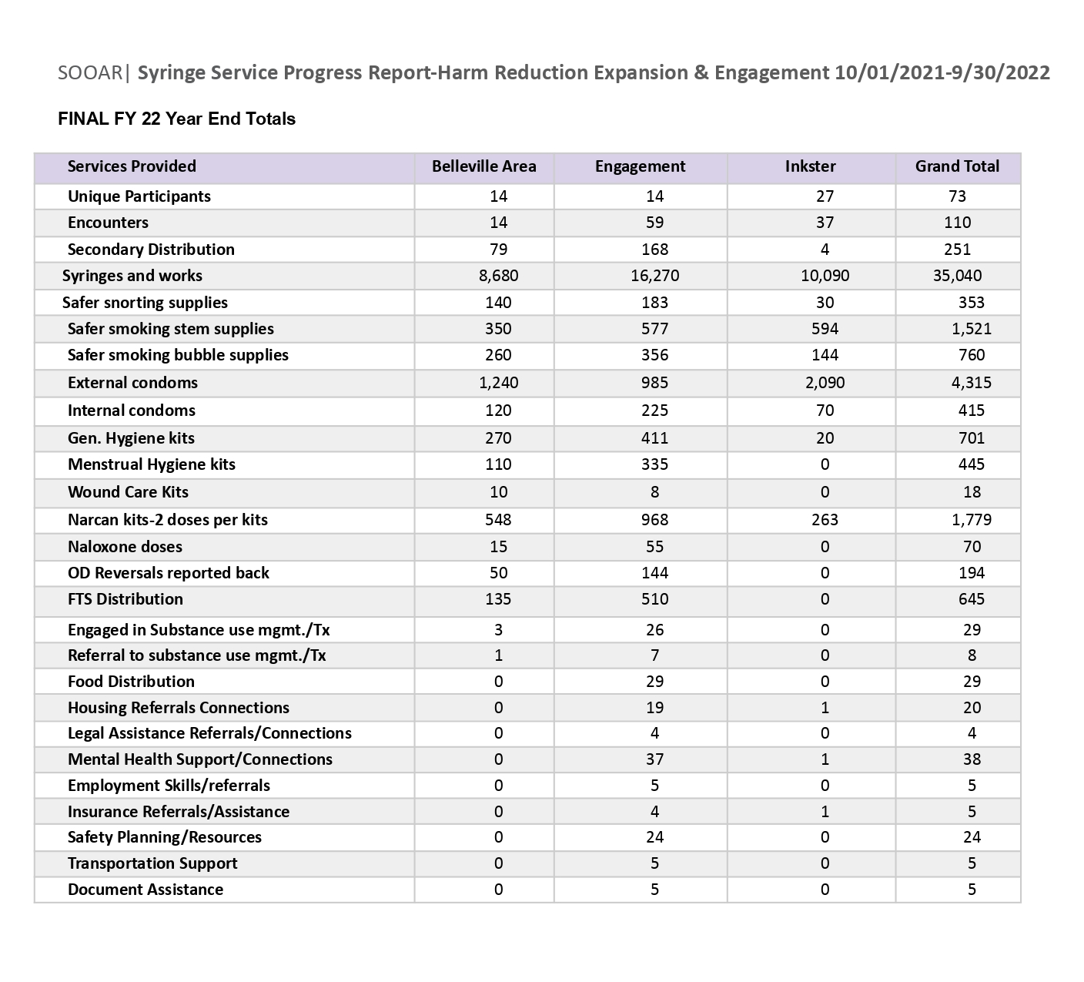

SOOAR Community Engagement Project FY2022
SOOAR’s engagement project for FY2022 aimed at identifying some of the barriers and concerns that prevent participants and other community members from accessing services and impacting their service experience within our Harm Reduction Program service area in Southeastern Michigan.

In its initial conception, the quantitative survey was meant to be the first phase in a two-part engagement project, with the second half focusing on qualitative interviews that would allow for more in-depth, narrative responses. Because the quantitative survey ended up being administered primarily to individuals that identify as LGBTQIA+ and use criminalized substances within SOOAR’s network, we also hoped to expand in the second phase to community members outside of SOOAR’s existing network. With the profound amount of interactions and support provided to participants and lack of capacity within the organization, and limitations within the context of criminalized substance use and COVID-19 safety concerns, the qualitative focus group was not attended and was omitted from these results and report.

Key Findings included an overwhelming amount of negative service experiences with Governmental Agencies such as: Michigan Department of Health and Human Services; Michigan Works!; Community Mental Health, and Law Enforcement and the Courts. In addition, service barriers including legal and safety, transportation, accessibility, stigma and discrimination for individuals and improvements and solutions were well supported and additional ideas were contributed to the survey. The selected engagement stories took place over the course of this project and impacted our participants and staff deeply, as barriers were beyond what harm reduction programs currently are able to offer, and profound systemic and structural barriers existed.

This project within its limitations hopes to provide motivation for comprehensive assessments and changes of various systems to address the social determinants of health and structural inequities that exist across Michigan. A healing-centered engagement is asset driven and focuses on well-being individuals want, not just the behaviors society wants people to stop, such as substance use.

People who identify as LGBTQIA+ in Michigan experience discrimination in employment, housing, and public accommodations. Recommendations were made with respect to the barriers and improvements expressed within our communities navigating in violent systems of oppression, through a trauma informed healing-centered lens, across each socio-ecological level.

Summary and Conclusions
From January 2022 through September 20, 2022, there have been 544 lives lost due to suspected drug overdose deaths in Wayne County, Michigan. Of the almost 400,000 Wayne County residents living in poverty, there are about 60,508 individuals ages 18-64 with a disability diagnosis. In 2019, there were 6,951 people living with HIV in Wayne County, with 285 people newly diagnosed with HIV, with 73% under the age of 34 years old. Even though Black/African Americans only make up 40% of the population, they account for 75.1% of newly diagnosed cases of HIV. During 2019, 4,652 (69.8%) of people living with HIV were virally suppressed. Of those persons unsuppressed, 32% are AA/Black, 35% report injection drug use and 35% identified as heterosexual males. In 2020, 2.5% of persons newly diagnosed with HIV identified as transgender.T he historical and continuous disenfranchisement of materials, resources, and access are a leading contributor to why these higher rates continue to increase within specific populations.

Hepatitis C Virus (HCV) has increased throughout Michigan, with 62% of those incarcerated individuals stating a lack of access to sterile supplies as a factor. Injection drug use and lack of access to sterile supplies in 18-39 year old's was reported in 82% of individuals living with HCV. Sexually Transmitted Infections (STI's) have increased dramatically among PWUD as well as skin, soft tissue infections and infective endocarditis.
Harm reduction programs such as SOOAR’s BOG program address the public health and social justice issues of HIV, viral hepatitis, non-fatal and fatal overdoses and substance use management utilizing a harm reduction philosophy, providing comprehensive services around these issues, ranging from prevention and testing to linkage to care, case management and treatment. By mobilizing services, clinical and harm reduction teams can bring care directly to individuals who have been historically disenfranchised and marginalized.

